HR EMPLOYEE DASHBOARD – PROJECT REPORT
Abstract
This project focuses on the analysis and visualization of Human Resource (HR) employee data to gain meaningful insights into workforce performance, attrition, promotions, workload, and workplace safety. Using an HR employee dataset, an interactive dashboard was developed to monitor key HR metrics such as average monthly working hours, employee evaluations, time spent in the company, promotions in the last five years, and work accidents across departments and salary levels. The dashboard enables HR professionals to identify trends, compare departmental performance, and support data-driven decision-making. This project demonstrates how data analytics and visualization tools can transform raw HR data into actionable insights that help improve employee management, retention strategies, and organizational efficiency.
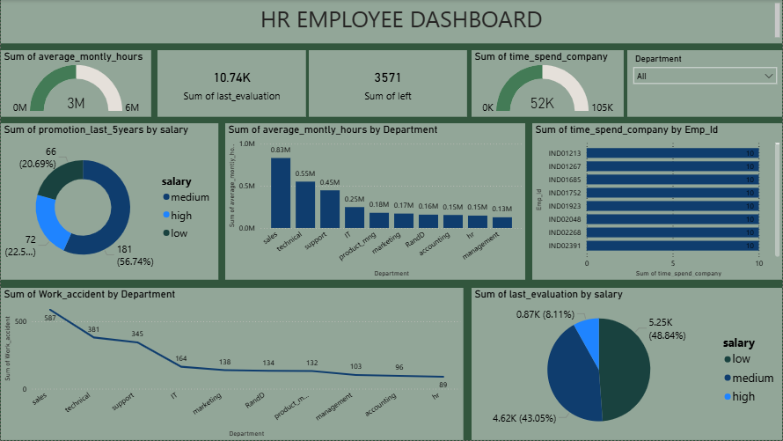
Introduction
Human Resource management plays a vital role in organizational success. This project focuses on analysing employee data to understand workforce behaviour, performance, retention, and departmental trends. The HR Employee Dashboard provides a visual and data-driven approach to help HR teams make informed decisions.
Objective of the Project
The main objectives of this project are:
- To analyse employee working hours, performance, and promotions
- To understand employee attrition (employees who left the company)
- To study department-wise workload and accidents
- To evaluate employee performance based on salary levels
- To support HR decision-making using data visualization
Dataset Description
The dataset contains employee-level HR information. Key columns used in this project include:
- Employee ID
- Department
- Salary (Low, Medium, High)
- Average Monthly Hours
- Time Spent in Company
- Last Evaluation Score
- Promotion in Last 5 Years
- Work Accident
- Left (Attrition status)
Tools and Technologies Used
- Microsoft Excel / CSV (Dataset)
- Power BI (Dashboard creation and visualization)
- Data Cleaning and Data Modelling techniques

Dashboard Overview
The HR Employee Dashboard presents key performance indicators (KPIs) and visual charts to summarize employee insights at a glance.
Key KPIs:
- Sum of Average Monthly Hours: Shows total working hours across employees
- Sum of Last Evaluation: Represents overall employee performance score
- Sum of Employees Left: Indicates attrition level
- Sum of Time Spent in Company: Shows total employee experience in years
Visual Analysis and Insights
1. Average Monthly Hours by Department
- Technical and Support departments show the highest working hours
- HR and Management departments have comparatively lower workload
- Helps identify workload imbalance among departments
2. Promotions in Last 5 Years by Salary
- Majority of promotions are observed in the low and medium salary groups
- High salary employees receive fewer promotions
- Indicates promotion opportunities are more frequent at lower levels
3. Time Spent in Company by Employee ID
- Highlights employees with long-term association
- Useful for identifying experienced and loyal employees

4. Work Accidents by Department
- Sales and Technical departments show higher accident rates
- HR and Accounting have minimal accidents
- Useful for improving workplace safety policies
5. Last Evaluation by Salary
- Medium salary employees have the highest evaluation scores
- Low salary employees contribute significantly to performance
- High salary employees form a smaller portion of evaluations
Key Findings
- High workload departments may face burnout risks
- Attrition is influenced by working hours and promotions
- Performance levels vary across salary categories
- Workplace safety needs improvement in specific departments
Business Benefits
- Helps HR teams monitor employee performance
- Supports retention and promotion planning
- Identifies risk areas for accidents and attrition
- Enables data-driven HR strategies
Conclusion
The HR Employee Dashboard successfully transforms raw HR data into meaningful insights. It allows HR professionals to monitor workforce trends, improve employee satisfaction, and make strategic decisions. This project demonstrates the power of data visualization in Human Resource Analytics.

Future Enhancements
- Add time-based analysis (year-wise trends)
- Include employee satisfaction scores
- Integrate predictive analytics for attrition
- Add filters for gender, age, and experience

